Metal-Expo’ 2008
Moscow, Krokus Expo, Pavillion 2
November, 11 – 14th
Hall 8
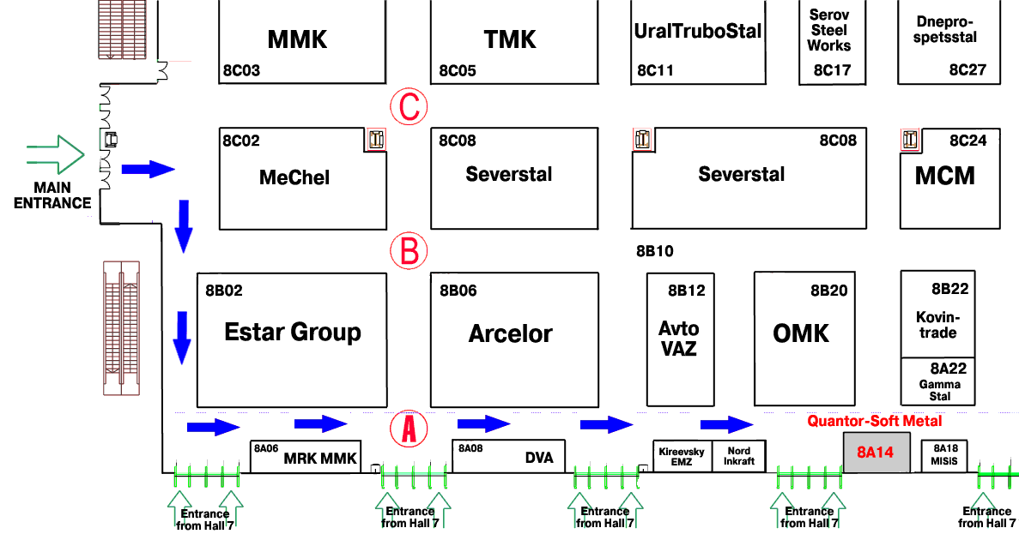
Booth 8A14 of Quantor-Soft Metal
